**Project -2**

**Deploy a static website on AWS**

**Table of contents**

* Introduction
* Architecture overview
* Components required
* Folder structure
* Step-by-step guide

**Introduction**

Deploying a static website on AWS S3 involves hosting the website's files (HTML, CSS, JavaScript, images, etc.) on an Amazon S3 bucket, making them publicly accessible, and configuring the bucket for static website hosting. This provides a cost-effective and scalable solution for serving static content, leveraging S3's reliability and availability**.**

**Architecture overview**

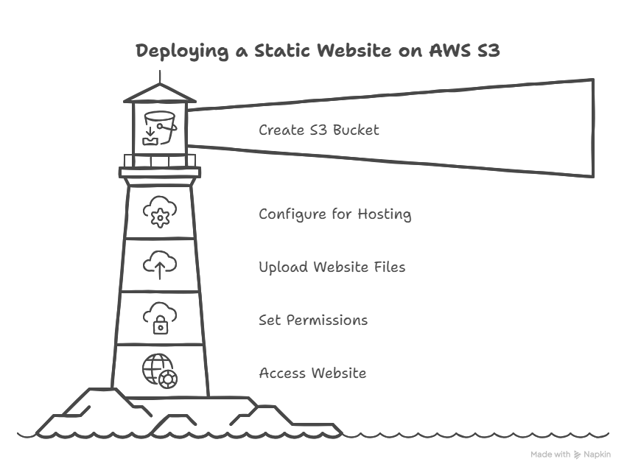

**Components required**

* Create s3 bucket
* Website files
* Static web hosting
* Permissions and access

**Folder structure**

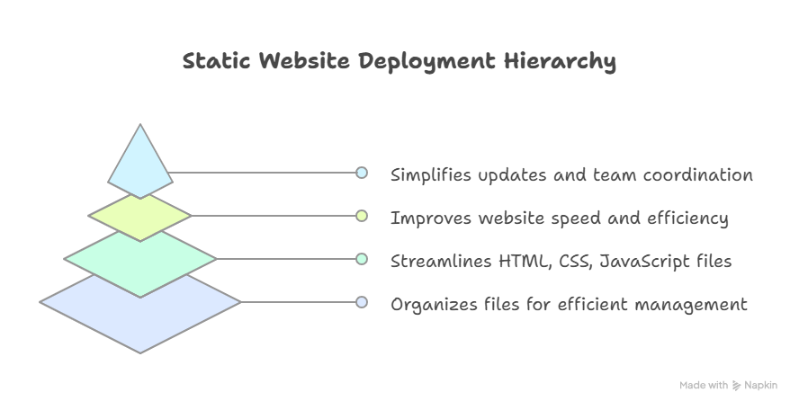

**Step by step guide**

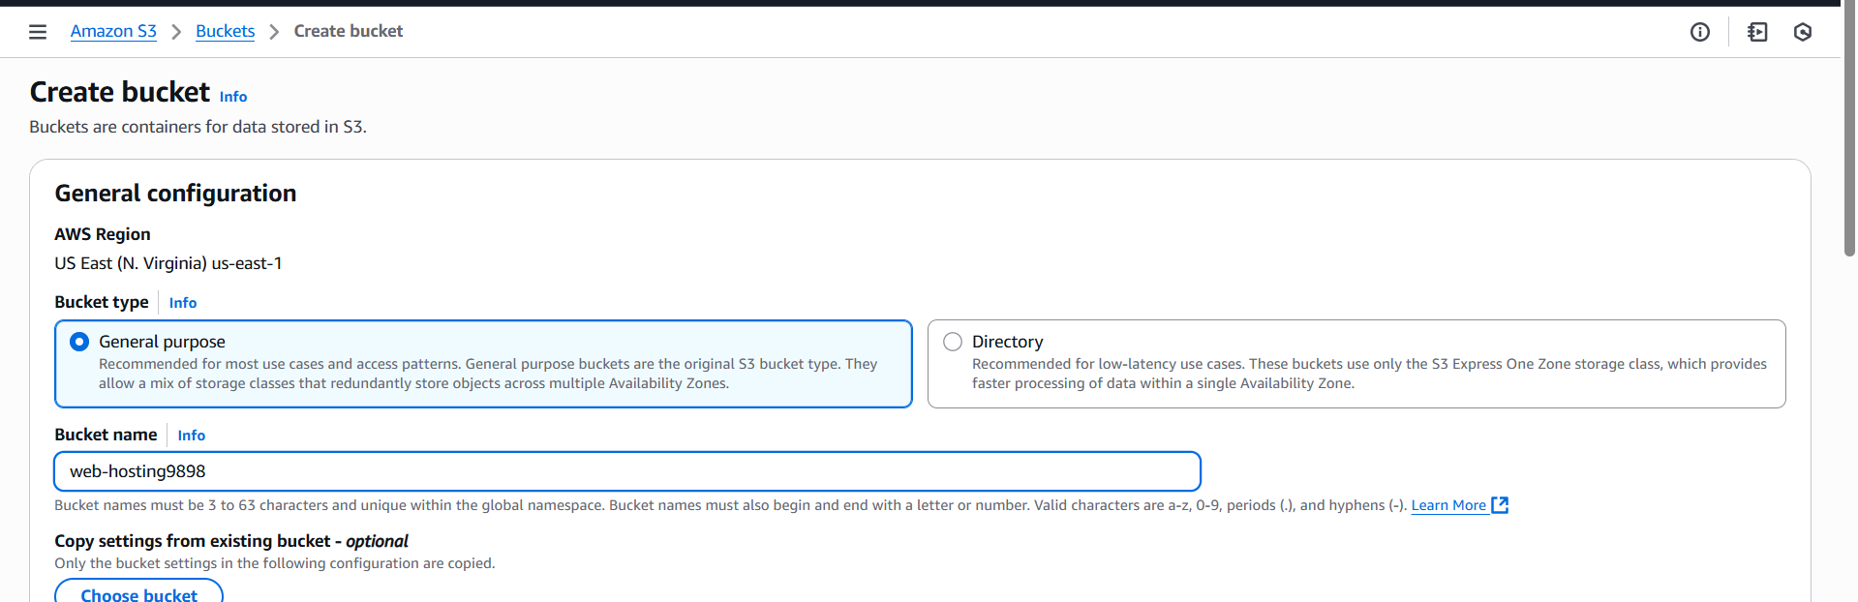Task-1) Create and s3 bucket.

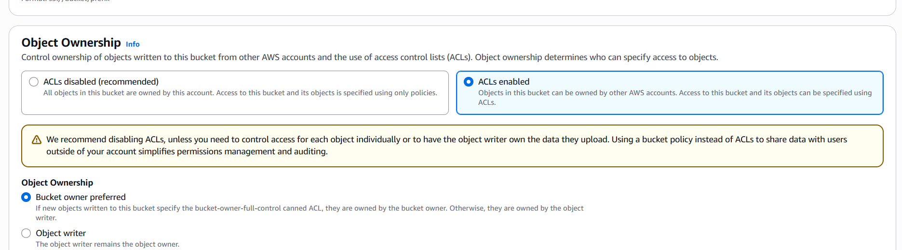Task-2) In object ownership enable the ACL.

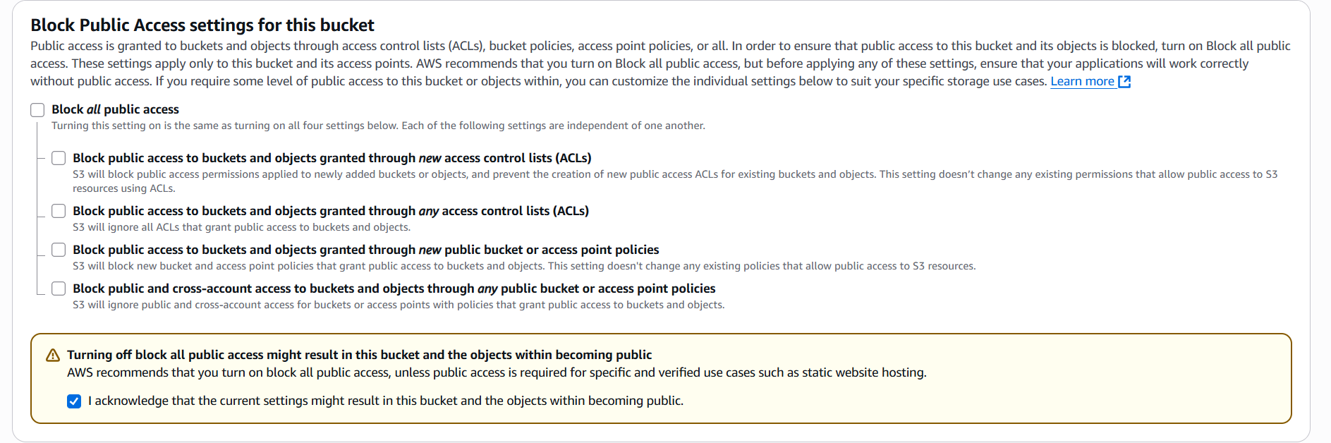Task-3) disable the block public access .

Task-4) create the bucket.

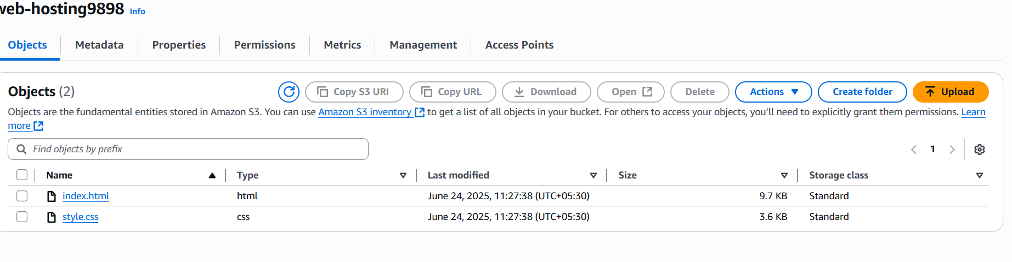Task-5) now upload the website files

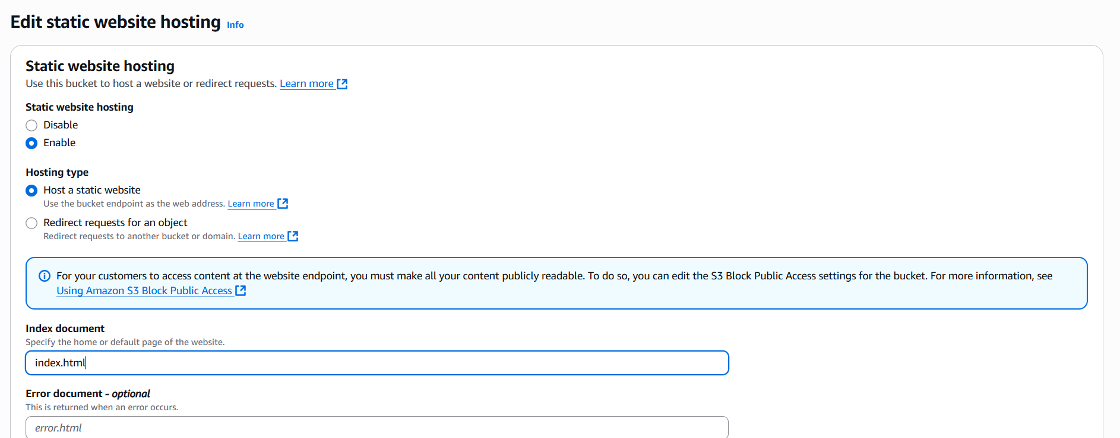Task-6) now go to properties and enable the static website hosting.

Task-7) click on save changes.

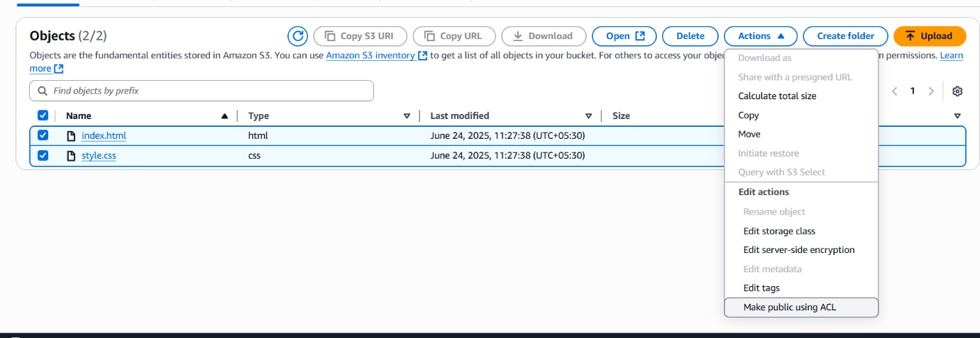Task-8) now go to the website files and click on actions and make it public.

Task-9) now copy the URL of your uploaded files and you can see your website .

By following these steps, you can successfully deploy a static website on AWS S3, providing a scalable and cost-effective solution for serving your content. Remember to review the security considerations and explore advanced features like custom domains and HTTPS for a more professional and secure setup.